1) In a private hospital, let’s assume all the patient details like PatientID, patient name, Type of disease, Date of admission, total expenditure and also doctor details are stored in Hospital database. Write a JDBC application to access patient and doctor details using Database access drivers.

**CODE:**

import java.sql.*;

public class Hospital {

    public static void main(String[] args) {

        try{

            Class.forName("com.mysql.jdbc.Driver");

            Connection con=DriverManager.getConnection("jdbc:mysql://localhost:3306/hospital","root","");

            PreparedStatement st = con.prepareStatement("SELECT ID,Name,Disease,DOA,Expenditure FROM patients;");

            ResultSet patient = st.executeQuery();

            System.out.println("Details of Patients:");

            while (patient.next()) {

                System.out.println("\nID: " + patient.getString("ID"));

                System.out.println("Name: " + patient.getString("Name"));

                System.out.println("Disease: " + patient.getString("Disease"));

                System.out.println("Date of Admission: " + patient.getString("DOA"));

                System.out.println("Expenditure: " + patient.getInt("Expenditure"));

             }

             st = con.prepareStatement("SELECT * FROM doctors;");

             ResultSet doctor = st.executeQuery();

             System.out.println("\nDetails of Doctors:");

            while (doctor.next()) {

                System.out.println("\nID: " + doctor.getString("ID"));

                System.out.println("Name: " + doctor.getString("Name"));

                System.out.println("Age: " + doctor.getInt("Age"));

                System.out.println("Qualification: " + doctor.getString("Qualification"));

             }

            con.close();

            }

        catch(Exception e){

            System.out.println(e);

        }

    }

}

**Database:**

Doctor:

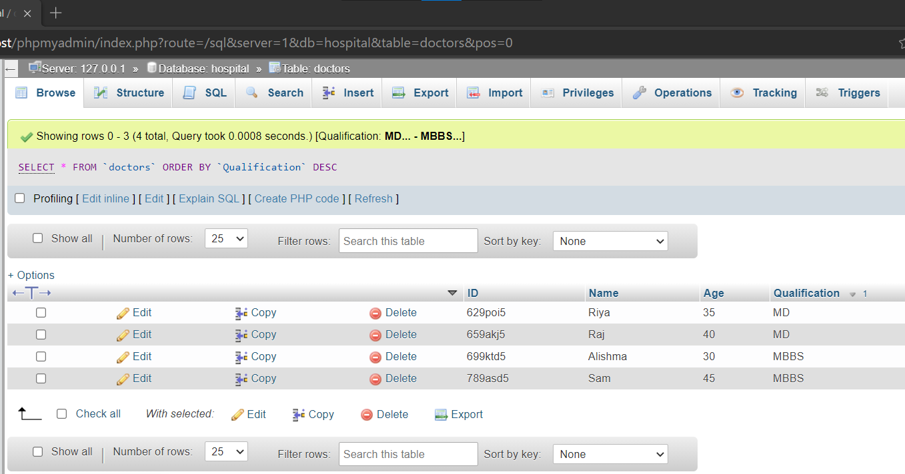

Patients:

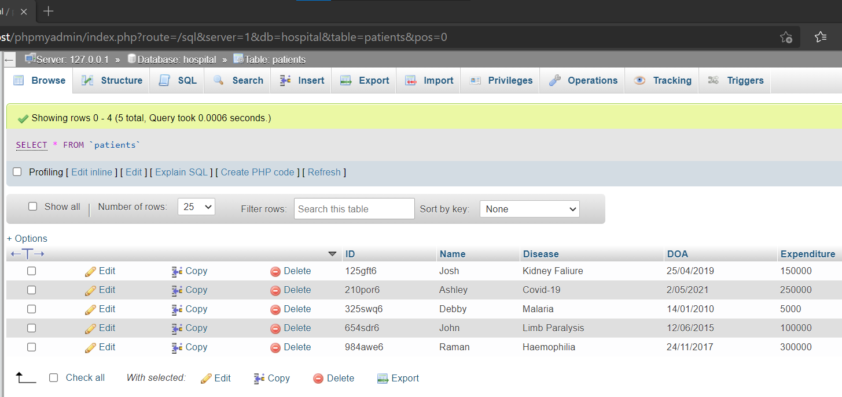

**OUTPUT:**

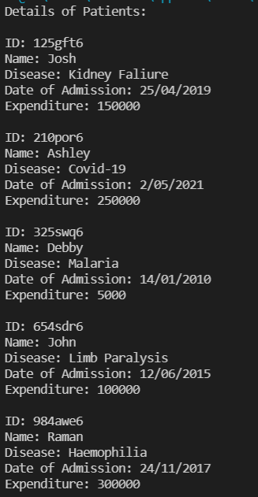

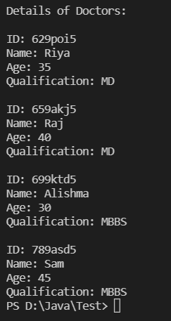

2) Telephone Billing System wants to store the call data in the form of a data table. Design a JDBC application that will read the data from the table also find the duration & units , display total amount in the duration & units and display the total amount in the current month bill for a given telephone.

**CODE:**

import java.sql.*;

public class Telephone {

    public static void main(String[] args) {

        try{

            Class.forName("com.mysql.jdbc.Driver");

            Connection con=DriverManager.getConnection("jdbc:mysql://localhost:3306/hospital","root","");

            PreparedStatement st = con.prepareStatement("SELECT * FROM telephone;");

            ResultSet rs = st.executeQuery();

            while(rs.next()){

                System.out.println("\nCustomer ID: "+rs.getString("ID"));

                System.out.println("Call Duration: "+rs.getInt("Duration")+" minutes");

                System.out.println("Unit: Rs "+(rs.getInt("Units")/100.0)+" per minute");

                System.out.println("Total Bill Amount: Rs "+((rs.getInt("Units")/100.0)*rs.getInt("Duration")));

            }

            con.close();

        }

        catch(Exception e){

            System.out.println(e);

        }

    }

}

**DataBase:**

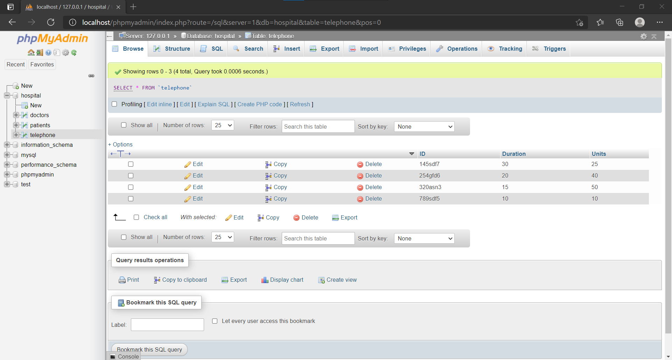

**OUTPUT:**

